**Contents**

**1.Preface…………………………………………………………………………………………………………………………………..2**

1.1 About This Guide…………………………………………………………………………………………………….….2

1.2 Intended Audience…………………………………………………………………………………………….……….2

1.3 Revision………………………………………………………………………………………………………………………2

**2. Getting Started………………………………………………………………………………………………………………………2**

2.1 Program Description……………………………………………………………………………………………..…….2

2.1.1 Displaying today’s date………………………………………………………….……………….……2

2.1.2 Displaying greeting message…………………………………………………….………………..…2

2.1.3 Displaying current time…………………………………………………………….………………..…2

2.1.4 Displaying number of remaining days……………………………………….…..…………..…2

2.2 Program Design..…………………………….……………………………………………………………………..…….3

2.1.1 Avoid using Hard coded numbers……………………………………….…..…………..……....3

2.1.2 Using “import” for used namespaces………………………………..….…..…………..….….3

**3. Program Modules…………………………………………………………………………………………………………….…….3**

3.1. main static method………………………………….………………………………………….……………….….…3

3.2. displayCurrentDate staticmethod………………………………….……….………..………………….….…4

3.3. displayGreetingMessage static method……………………………………………………………….….…4

3.4. displayTime static method………………………………….……………………………………………….….…4

3.5. displayRemainingDays static method………………………………………………………………….….…4

**4. Data, Test data and known problems……………………………………………………………………………………5**

4.1 Data and File Description…………………………………………………………………………………………..5

4.1.1 Subsection……………………………………………………………………………….…………………5

4.1.2 Subsection………………………………………………………………………………….………………5

4.2 Test data and results………………………………………………………………………………….………………5

4.3 Known problems (Bugs)………………………………………………………………………………….………….5

**1.Preface:**

1.1 About This Guide:

This reference manual aims to provide the needed guidance to user while using this application.

2.2 Intended Audience:

This manual is intended to users with basic knowledge of software applications.

No needed for having previous extensive knowledge, only minimum level of knowledge is required.

1.3 Revision:

The “Device” application, I a simple java program, and has been developed under the supervision of the previous entitled project manager.

And the program had undergone some changes under the supervision of the current project manager.

**2.Getting Started:**

After the completion of this section, the user should have very good understanding of the “Device” application’s structure and how the program functions.

2.1 Program Description:

From these following sections, a programmer would be able to understand how each method and module of the application runs.

Generally, the main functionality of this application is to display today’s date, a greeting message to the user, the current time, along with calculating the number of days remaining in this current year.

2.1.1 Displaying today’s date:

A message is displaying the current date in “Month Day Year” format.

2.1.2 Displaying greeting message:

Display a greeting message to the user, according of the current time, whether afternoon or evening.

2.1.3 Displaying current time:

A message is displaying the current time in letters not digits.

2.1.4 Displaying number of remaining days:

A message is displaying the number of remaining days to the end of the current year.

2.2 Program Design:

Program was designed in simple way to display required messages to the user, once the application is run, as shown in figure 1-1.

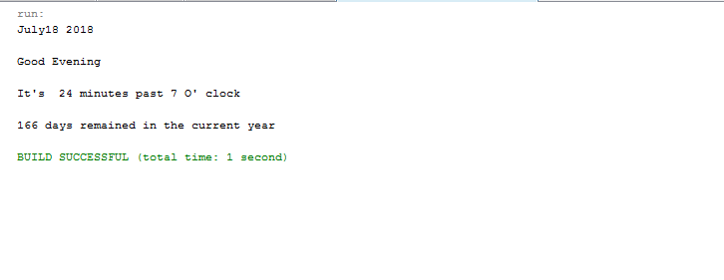

**Figure 1-1**

2.1.1 Avoid using hard coded numbers:

Due to the hardships to reach a hardcoded number in a java program, and in order to increase the quality provided, hard codded numbers were replaced by static variables.

2.1.2 Using “import” for used namespaces

According to quality standards of a software program, it is recommended not to use packages’ full path through the coding, accordingly that problem was overridden by using an “import” statement and just instantiate the object through the code.

**3. Program Modules:**

The application uses import statement for required Calendar library.

**Module name:** Class DeviceMessedUp

**Functionality and purpose**: Display message to the user.

**Input data:** no input is required.

**Output data:** Message showing today’s date, a greeting message to the user, the current time, along with calculating the number of days remaining in this current year.

3.1. main static method:

Module name: main

Functionality and purpose: calling methods to display proper messages to the user

Input data: no input is required.

Output data: Display all the messages to the user.

3.2. displayCurrentDate static method:

Module name: displayCurrentDate

Functionality and purpose: the method applies Calendar instantiation for getting Current Date; declare integer variables for day, month and year,

And use a Switch casing for checking which month was returned.

Input data: no input is required.

Output data: displaying the current date to the user.

3.3. displayGreetingMessage static method:

Module name: displayGreetingMessage.

Functionality and purpose: method makes static variables and integer variables declarations, along with Calendar instantiation for getting Current hour.

An if conditional is used to check hours to afternoon or evening, whether it is Morning, afternoon, or evening.

Input data: no input is required.

Output data: display greeting message to the user after determining is it Morning, afternoon, or evening.

3.4. displayTime static method:

Module name: displayTime.

Functionality and purpose: Calendar instantiation for getting Current minutes, with

Integer variables declarations for minutes and hour

A conditional if is used to check, if it is not exactly zero minutes and displaying the current hour accordingly.

Input data: no input is required.

Output data: display current hour and minutes according to 12 formate.

3.5. displayRemainingDays static method:

Module name: displayRemainingDays.

Functionality and purpose: A calender instantiation for getting Current year,

With integer variables declarations for year and passed days in the current year,

Another calendar instantiation for getting remaining days

integer variables declarations for remaining days.

Input data: no input is required.

Output data: displaying remaining days for current year to the user.

**4. Data, Test data and known problems:**

4.1 Data and File Description:

No external files or records accessed by the DeviceMessedUp Class, and no data input is required to be provided.

4.2 Test data and results:

No input required, consequently no diverse range of probability in the output obtained from this application.

4.3 Known problems (Bugs):

Currently no detected bugs were discovered.